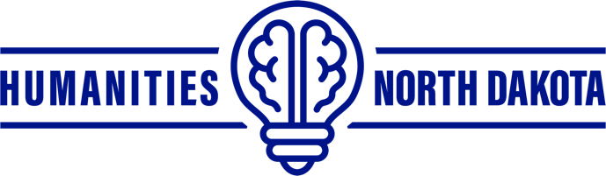

Humanities North Dakota is a statewide nonprofit dedicated to lifelong learning. Please take a few minutes to fill out this survey to help us strengthen our programming. Thank you for your participation.

Audience Evaluation
Where do you currently reside?
City: _____________________ State: ______
Which category below includes your age?
17 or younger | 18-20 | 21-29 | 30-39 | 40-49 | 50-59 | 60-69 | 70 or older
How do you identify?
male | female | nonbinary | other
Is this your first time at a Humanities North Dakota sponsored event?
yes | no
What is the highest level of school you have completed or the highest degree you achieved?
 | Less than high school degree |  | Associate degree
 | High school degree or equivalent (e.g., GED) |  | Bachelor degree
 | Some college but no degree |  | Graduate degree
What do you consider your race?
 | White |  | Hispanic/Latino
 | Black or African American |  | Multiracial
 | American Indian or Alaskan Native |  | Other, please specify
 | Asian |  | ________________________

Audience Evaluation
Please rate how interesting and informative you found this event?
Not Very Interesting & Informative | Somewhat Interesting & Informative | Moderately Interesting & Informative | Very Interesting & Informative | Extremely Interesting & Informative
Please provide any additional comments or feedback on today’s event:

What other cultural and educational events or programs would you like to see in your community? What topics or speakers interest you?

If you would like to subscribe to Humanities North Dakota’s mailing list to receive updates on educational programs happening across the state please fill out the information below:
First Name: Last Name:
Address:
City: State: ZIP Code:
Email Address: __

Thank you for taking the time to fill out our survey. We rely on your feedback to help us improve our services. Your input is greatly appreciated.

